**CMU B.Sc. (HONS) SE /B.Sc. (Hons) BIS- ASSIGNMENT FEEDBACK SHEET –ICBT CAMPUS**

|  |  |  |  |  |  |  |  |  |  |  |
| --- | --- | --- | --- | --- | --- | --- | --- | --- | --- | --- |
| **Student Details ( Student should fill the content)** | | | | | | | | | | |
| Name | | | Lakitha Naranjan Ranwala | | | | | | | |
| Student ID | | | KD/BSCSD/15/09 | | | | | | | |
| **Scheduled unit details** | | | | | | | | | | |
| Unit code | | | CIS6003 | | | | | | | |
| Unit title | | | Advanced Programming | | | | | | | |
| Unit enrolment details | | | Year | | 3 | | | | | |
| Study period | |  | | | | | |
| Lecturer | | |  | | | | | | | |
| Mode of delivery | | | Full Time | | | | | | | |
| **Assignment Details** | | | | | | | | | | |
| Nature of the Assessment | | | **Course work** | | | | | | | |
| Topic of the Case Study | | | **Online loan offering system to buy items and it in installments** | | | | | | | |
| Learning Outcomes covered | | | **1,2,3** | | | | | | | |
| Word count | | | 4000 | | | | | | | |
| Due date / Time | | | March 10, 2023 | | | | | | | |
| Extension granted? | | | Yes | No | Extension Date | | | |  | |
| Is this a resubmission? | | | Yes | No | Resubmission Date | | | |  | |
| **Declaration** | | | | | | | | | | |
| I certify that the attached material is my original work. No other person’s work or ideas have been used without acknowledgement. Except where I have clearly stated that I have used some of this material elsewhere, I have not presented it for examination / assessment in any other course or unit at this or any other institution | | | | | | | | | | |
| Name/Signature | | | Lakitha ranwala | | | | Date | | 2023/4/6 | |
| **Submission** | | | | | | | | | | |
| Return to: | | |  | | | | | | | |
| **Result** | | | | | | | | | | |
| Marks by 1st Assessor |  | Signature of the 1st Assessor | | | | | |  | | **Agreed Mark** |
| Marks by2nd Assessor |  | Signature of the 2nd Assessor | | | | | |  | |
| **Comments on the Agreed Mark.** | | | | | | | | | | |
| **For Office use only (hard copy assignments)** | | | | | | | | | | |
| Receipt date |  | | Received by | | |  | | | | |

|  |  |  |  |  |  |  |
| --- | --- | --- | --- | --- | --- | --- |
| **STUDENT NAME:  *lakitha newranjan ranwala*** | | | | | | **STUDENT NUMBER:**  KD/BSCSD/15/09 |
| **Module Number & Title**: Advanced Programming | | | | | | **Semester: 1** |
| **Assignment Type & Title:** Advanced Programming - Writ 1 | | | | | | |
| **For student use: *Critical feedback on the individual progression towards achieving the assignment outcomes*** | | | | | | |
|  | | | | | | |
| **For the Assessors’ feedback**  **Indicate the Task number strength and Weaknesses and the marks for each task** | | | | | | |
| **Task No/Question No** | **Strengths** | | | | | |
| **Task No / Question No** | **Weaknesses** | | | | | |
| **Areas for future improvement** | | | | | | |
|  | | | | | | |
| **Marks** | | | | | | |
| **Task /Question No** | | **Allocated Marks** | **Awarded Marks** | | **Remarks** | |
|  | |  |  | |  | |
|  | |  |  | |  | |
|  | |  |  | |  | |
|  | |  |  | |  | |
|  | |  |  | |  | |
| **Total Marks** | |  |  | |  | |
| **Name and the Signature of the Assessor** | | | |  | | |
| **Date** | | | |  | | |

Upon successful completion of this module, you will have demonstrated:

* Demonstrate fluency in contemporary programming languages, development tools and environments.
* Evaluate and demonstrate the theory and concepts of contemporary/industry standard programming and design in the software development life cycle.
* Demonstrate awareness of industry standards of professional and ethical software development, software carpentry and codemanship.

Coursework –**Online loan offering system to buy items and it in installments**

“Bumble bee: Buy first and pay later” is a well reputed online loan providing application. This application lets any person above age 18 to make purchases online within the maximum entry budget up to 15,000LKR.The loan can be paid basically in 3 interest free installments.

Suppose that the application is introduced and already launched, but they need to have the admin system (web view) application to be developed from your end.

The system administrator should be able to get the customer details (registered users) listed out with their information like customer id, full name, date of birth, loan balance, used amount, installment plan etc. Also customers should be able to manage everything about products, categories, brands and inventory management (Update details, remove details, add new details etc.). The admin login should be provided separately.

Additionally, the web view should let the customers get registered to the system themselves separately using a separate option called “Register”.

**Up to now, the customers are only supposed to use this option to register to the system in web view, but the login and the using of the system to do shopping is expected only through the mobile app.**

Provide a well-designed, user friendly system addressing the following features:

* System should have differential access rights to the system users.
* Interactive user friendly interfaces
* Clear implementation of the business flow via the system.
* Design & implement suitable sets of reports, which you think will add more value to the entire business
* Use test driven development and include test classes to test your application

Students are free to make necessary assumption on system design & granting access permissions

other than mentioned within the scenario, but all suggestions must be well explained with the

Valid reasons.

Students can add any functionality which will enhance the system and make the proposed

Solution more comprehensive.

**Use Harvard referencing to properly acknowledge all the external sources you use.**

**Your tasks**

**Tasks A:**

Provide a requirement specification for the proposed system. (06 marks)

**Tasks B:**

Provide the UML diagrams for the given problem with clear explanations on the design decisions. Derive detailed Use Case diagram, Class diagram & a sequence diagram. Whenever necessary document the relevant assumptions you made.

(09 marks)

**Tasks C:**

There are many system design patterns available in system development. Critically evaluate singleton, factory and abstract factory design patterns and apply the most suitable design pattern for your system development.

(15 marks)

**Tasks D:**

Develop an interactive set of interfaces to get the necessary user inputs. Make sure to implement proper validation mechanisms in order to restrict invalid entries to the system. Come up with suitable set of reports, which you will think add more value to your system

1. Your program must be a distributed application with web services
2. Your program should make use of a proper database to store information

(30 marks)

**Tasks E:**

Document the test plan and explain how you used test driven development in this scenario and do a test automation to achieve that. This includes test rationale, test plan, test data and proper application of the test plan (LO II)

(15 marks)

**Tasks F:**

Create user and technical documentation for the developed solution. (10 marks)

**Tasks G:**

Create your own Git/ GitHub repository which is public to access and upload /deploy the changes of the software project you have developed in it. Share the repo link within the documentation. Update it with several number of versions where modifications applied per each day, that you have applied the new features into which was initially uploaded with. Version control techniques you have used throughout the development should be highlighted and documented properly. Demonstrate workflows deployed with the Git repository.

(15 marks)

|  |  |
| --- | --- |
| Criteria | Marks |
| Out of 10 |
| Errors in the documentation | 0-3 |
| Acceptable standard of documentation with poor explanations | 3-5 |
| High standard of documentation with screen shots & average explanations | 5-7 |
| Professional standard of documentation with screen shots & good explanation | 5-10 |

**Task (G) contains 15 marks**

|  |  |
| --- | --- |
| Criteria | Marks |
| Out of 15 |
| Poor/no any Git version control, deployment, workflows used demonstrated | 0-3 |
| Git Repo/GitHub is used in creating a repository only and uploaded the initial version only | 3-6 |
| Git repo created, initial version of project uploaded and several versions were updated and deployed with changes but no any workflow or version control technique is demonstrated. | 6-10 |
| Git repo creation, accessibility restrictions, versioning and version control techniques, workflow(CI/CD) demonstrated and deployment of changes and the latest updated version is done and demonstrated in documentation | 10-15 |

# **01) Requirement specification for bumble bee system management dashboard**

1. **INTRODUCTION**

## **PURPOSE**

Bumble Bee is a financial company that offers customers the option to purchase products and pay the total cost in three installments. To manage inventory for this project, an inventory management website called "Bumble Bee Buy First and Pay Later" was developed, and a mobile app was created for customers to make purchases and payments.

To fulfill the requirements, an admin dashboard was designed and created to enable administrators to manage specific tasks within the system. The dashboard allows administrators to add, delete, and update records, generate reports, and search for specific data as needed. Additionally, the dashboard provides a consolidated view of data and metrics related to business performance, such as sales, customer and user information, and product stocks. This allows administrators to monitor and analyze data in real-time or near real-time, providing up-to-date information on the main system.

By utilizing a dashboard, administrators can save time and increase efficiency in gathering and analyzing data manually. This can ultimately lead to increased productivity and better decision-making. Overall, the admin dashboard is a crucial component of the Bumble Bee inventory management system, providing a user-friendly interface for administrators to manage and monitor critical data and metrics.

# **1.2 Stakeholder requirements**

In original requirements its basic need was inventory management and handling mains features as user, products and category’s and the product brand and monitors sales of each product this UI and features made for administrator.

As requested this dashboard will be provide basic add edit delete and update features to admin system that contains add users and edit user details by admin and deactive accounts and as requested we designed and created a product inventory that admin can add and delete product as well as mange stocks details by adding and quantities and dashboard will show outs of stock relevant to admin when need and sales tables that provide good information to admin weather if user completes the payment and still its on pending. Dash board have data privacy its obtain user details and give editing features to the admin but admin is not able to change passwords to user account but in the controls admin can detect and deactive user accounts.

#### **1.2.1 PROJECT SCOPE**

* Admin can manage category, users, products and stock through the system.
* Users can be register
* Admin must have login system
* Admin need to be check sales. And generate reports.

# **1.3 Operating environment**

The following document outlines the operating environment for a user-friendly web application system that provides easy access, high privacy, accurate functionality, and an enhanced user experience.

Front-end technology:

The system utilizes several front-end technologies to create a seamless user interface, including HTML for structuring jsp,web pages, CSS for styling and layout, JavaScript

Back-end technology:

The system employs a variety of server-side technologies to ensure efficient and reliable operation, including programming languages such as java servlet and databases like MySQL

Conclusion:

Overall, the operating environment for the web application system is optimized for user-friendliness, privacy, accuracy, efficiency, and performance, incorporating a variety of front-end and back-end technologies, robust security measures, and high-performance infrastructure.

* Database: MySql
* Platform: java

**1.4 Design constrains**

* This system is expected to run mainly on the Windows platform.
* Security risks may be involved.
* The details given by the users when registering should be stored in the database properly.
* Time constraint to manage the project.

**1.5 User interfacing designs**

1. **Admin Interface:**

Manages and monitors all the users and actions in the entire system by maintaining the database of cakes and orders.

1. **User interface**

User registration who can registered to the system.

**1.6 Software requirements**

The system is developed using Java language and SQL database.

* Database: Microsoft SQL.
* Developing tool: eclipse ide

**1.7 hardware requirements**

* Intel Dual Core processor or above.
* Mouse and keyboard.
* Hard drive with minimum GB capacity or ssd

**1.6 Communication interfaces**

Bumble bee system is a standalone web-based system. Therefore, it does not require any communication interfaces.

1. **SYSTEM FEATURES**

## **2.1 DESCRIPTION AND PRIORITY**

the system maintain information of all product and categories and all the users information.

## **2.2 RESPONSE SEQUENCES**

* Search for products names and codes.
* Search for brads names and codes.
* Search for user name and information’s.
* Search for products names and codes.
* Displays a detailed list of available stock.
* Get information of sales and place orders.
* Search for categories name and information’s.

## **2.3 FUNCTIONAL REQAIRMENT**

* **Registration:** This feature is used by the admin and customer for register to the system. They are required to enter first name, last name, email, address, contact, password.
* **Login:** This feature is used by the admin to login into system. They are required to enter username and password before they are allowed to enter the system. The email and password will be verified and if invalid email or password admin or customer is allowed to not enter the system.
* **Add user:** This feature allows to register user to the system. For that required to enter email, last name ,first name, contact ,password.
* **Edit user:** This feature allows to edit registered user. For that required to enter email, last name ,first name, contact ,password.
* **Delete user:** This feature allows to deactivate user.
* **Add categories:** This feature allows to add new categories the system. For that required to enter category name.
* **Edit categories:** This feature allows to edit existing category to the system. For that required to enter category name.
* **Delete categories:** This feature allows to deactivate a category
* **Search category:** This feature allows to search a category For that required to enter category name.
* **Add products:** This feature allows to product user to the system. For that required to enter product name.
* **Edit products:** This feature allows to existing product user to the system. For that required to enter category name.
* **Delete products:** This feature allows to deactivate product
* **Search products:** This feature allows to search a product For that required to enter product name.

1. **NONFUNCTIONAL REQUIREMENTS**
   1. **PERFORMANCE REQUIREMENTS**

The Product Stock Management System is an innovative Java-based web application that leverages the capabilities of the underlying hardware and software components of the computer system to enhance its overall performance. This intelligent system is designed to adapt dynamically to the available resources and optimize the usage of the system's hardware and software components. By leveraging the power of Java, the system is able to deliver robust performance and scalability, ensuring seamless and efficient management of product stock data. The system is a prime example of how modern software applications can utilize the latest technologies to improve their functionality and usability.

* 1. **SAFETY REQUIREMENTS**

It is essential to install antivirus software as a significant portion of the database can suffer from catastrophic failures, such as disk failure, leading to severe damage. Additionally, maintaining backups is crucial to prevent any loss of data. This precautionary measure ensures the continuity and protection of the database from potential threats or disasters.It is essential to install antivirus software as a significant portion of the database can suffer from catastrophic failures, such as disk failure, leading to severe damage. Additionally, maintaining backups is crucial to prevent any loss of data. This precautionary measure ensures the continuity and protection of the database from potential threats or disasters.

**3.2 SOFTWARE QUALITY ATTRIBUTES**

# To ensure optimal efficiency and effectiveness, regular reviews of the system are required, and the system must be able to perform its operations without any bugs or errors. It is crucial to maintain a bug-free environment to prevent potential issues and ensure the smooth functioning of the system. Therefore, it is essential to conduct regular assessments and evaluations to identify any areas for improvement and address any issues promptly. By doing so, the system can continue to function at its best, delivering reliable and efficient results to users.

# **02) UML diagrams for the given problem with clear explanations.**

**USE CASE DIAGRAM**

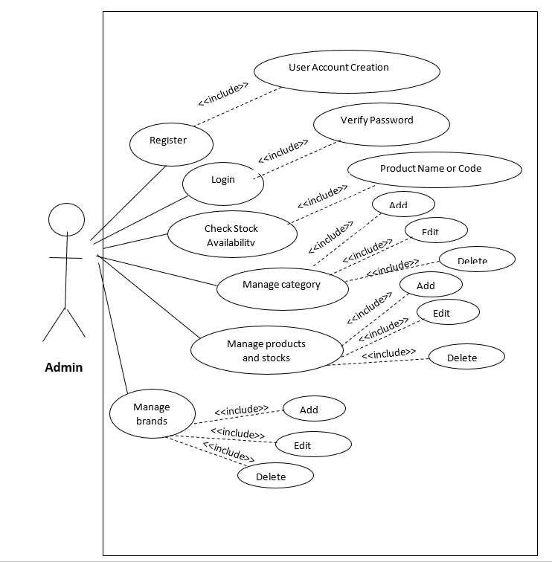

Figure 1:use case diagram

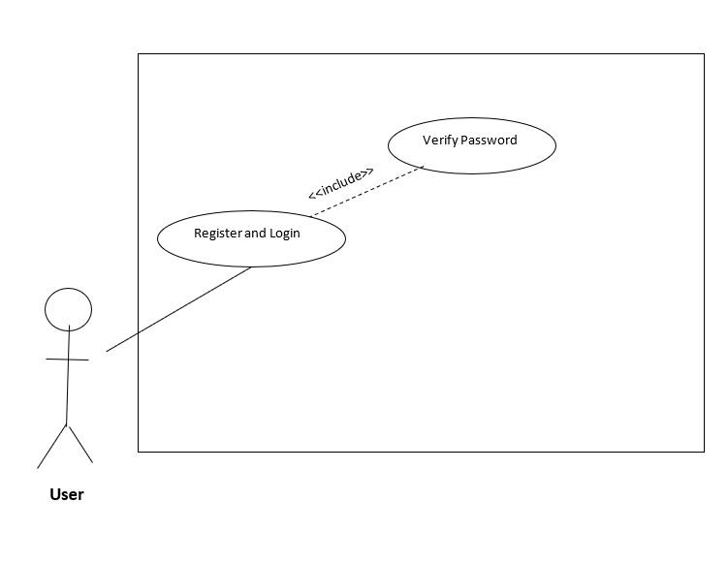

Figure 2:use case diagram

The UML use case diagram provides a comprehensive overview of the relationships between use cases, actors, and systems involved in a process. The diagram consists of oval shapes that represent use cases, and lines that indicate the interactions between actors and their corresponding use cases. This allows viewers to easily identify the specific points at which each actor participates in the process and see the overall involvement of each actor throughout the entire process. In this particular diagram, there are two actors: Admin and Customer, each with their own set of associated use cases. Overall, the diagram provides a useful visual representation of the use cases and actors involved in a process.

|  |  |
| --- | --- |
| **Actor** | **Description** |
| Admin | Admin is able to register & login, manage category, manage data and stock, mange product and check stock availability., mange brand, mange users |
| Customer | Customer is able to register |

|  |  |
| --- | --- |
| **Use Case** | **Description** |
| Login | This action enables by adding personal information to the system and enables them to log in to the system. |
| Register | This function enables to user to register there accounts. |
| Manage Category | This function enables the admin to add, delete, edit and search categories from the system. |
| Manage products | This function enables the admin to add, delete, edit and search data & stock from the system. |
| Manage brand | This function enables the admin to add, delete, edit and search brands from the system. |
| sales | This function enables the admin to monitor orders from the system and monitor payments |

**SEQUENCE DIAGRAM**

1. **Add product**

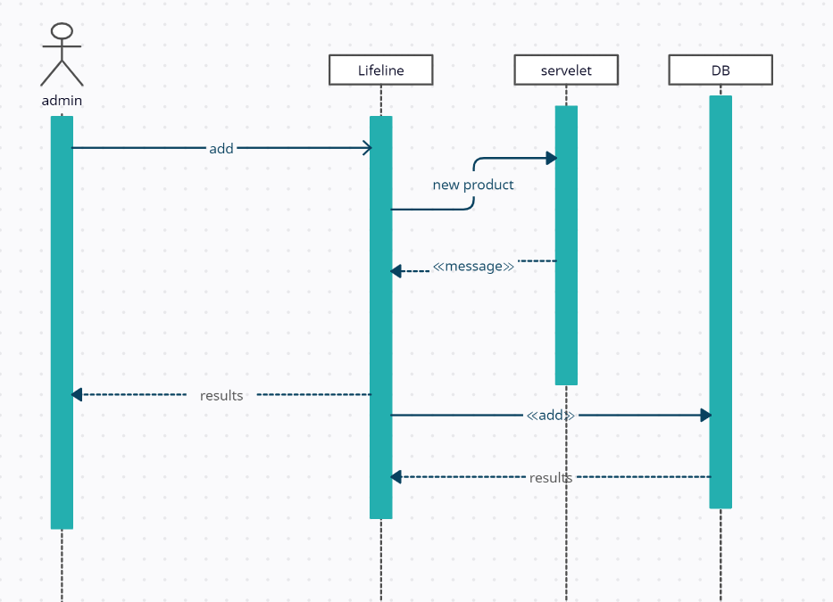

**Figure 3: Sequence Diagram**

1. **Edit product**

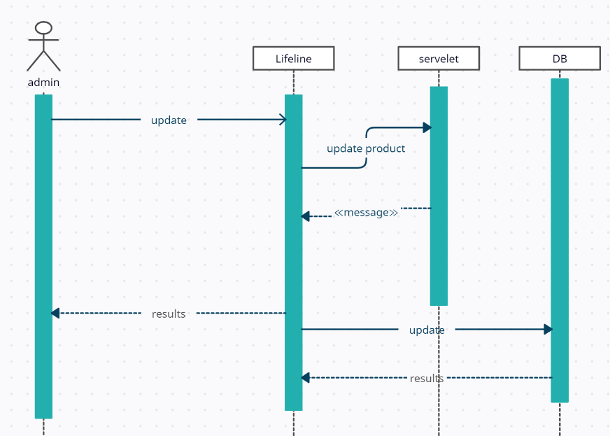

**Figure 4: Sequence Diagram**

1. **Delete product**

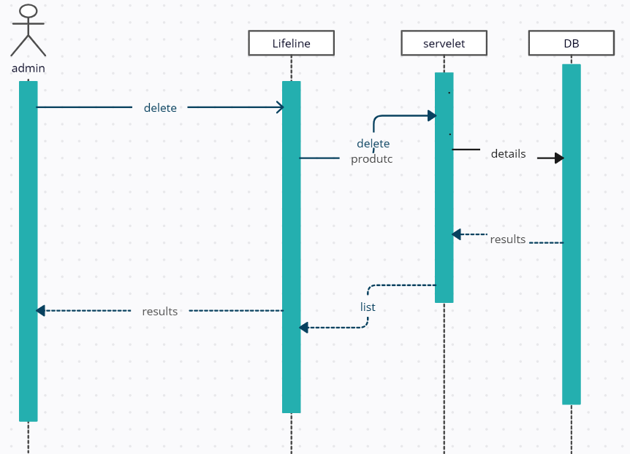

**Figure 5: Sequence Diagram**

1. **Search product**

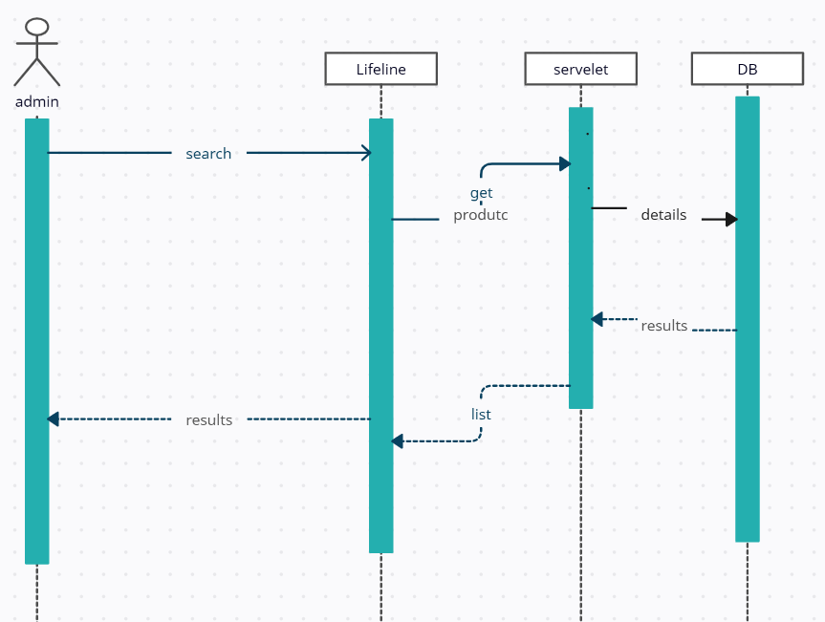

**Figure 6: Sequence Diagram**

**CLASS DIAGRAM**

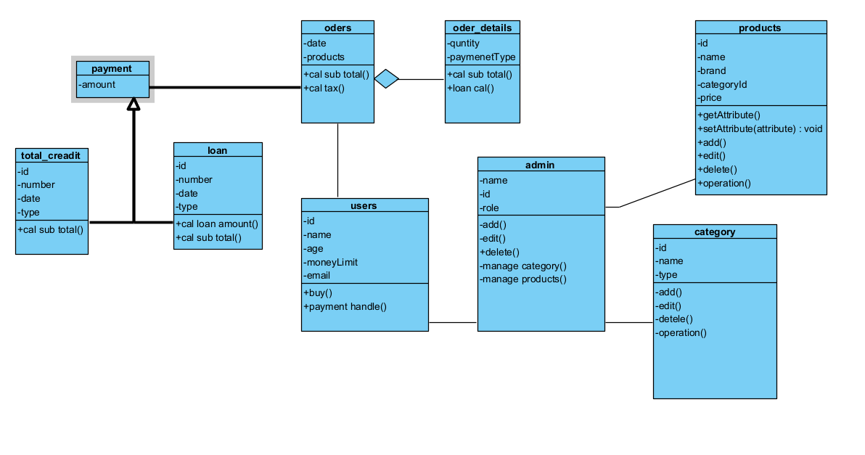

# **03) Development of bumble bee system**

**DB connection**

To establish a database connection using the factory method pattern, you would typically create a factory class that encapsulates the process of creating and configuring database connections. This factory class would have a method that clients can call to obtain a new database connection.

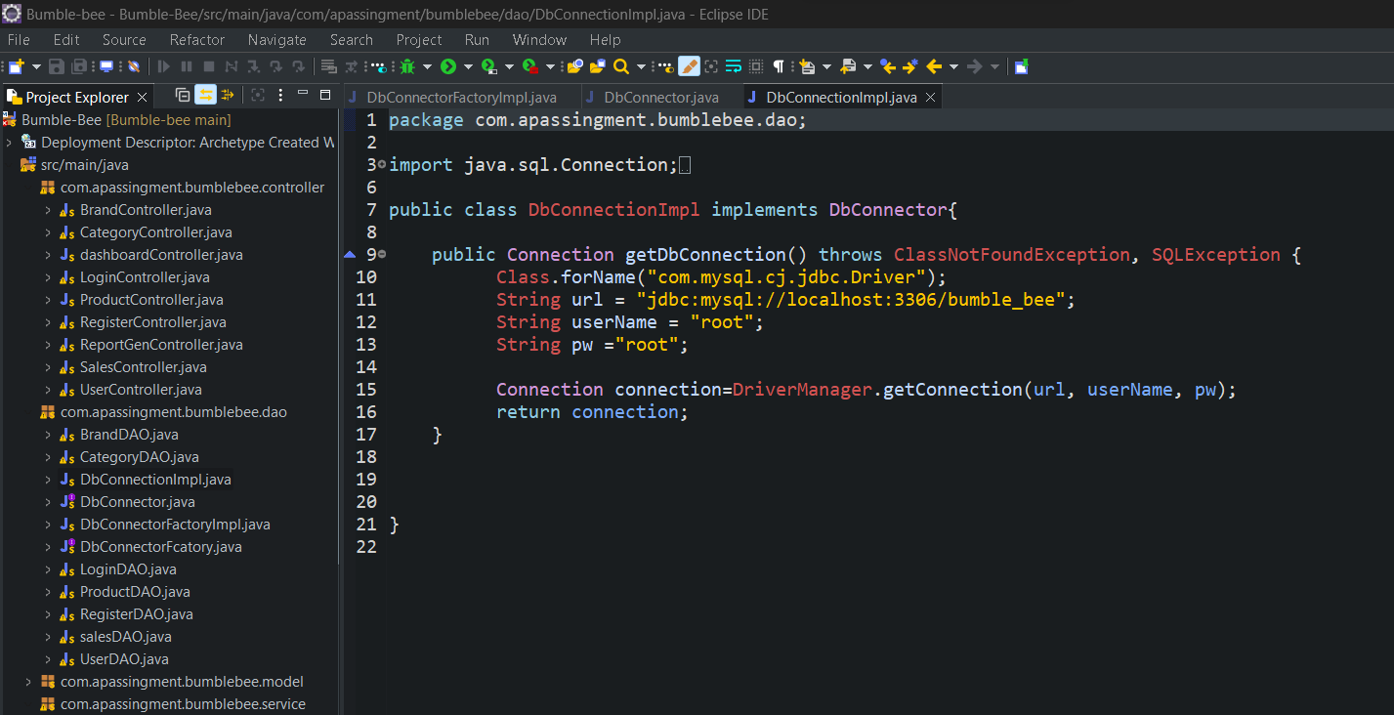

* Calling the connection
* 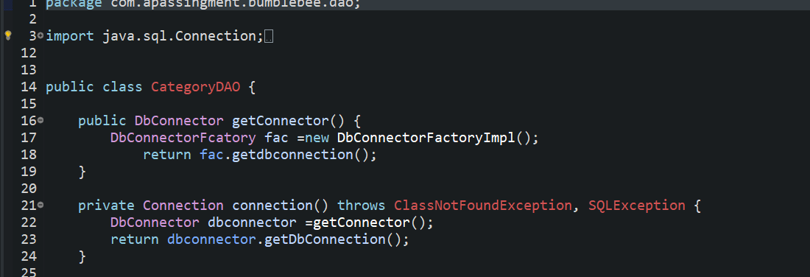

# **04) Different types of design patterns in java.**

Design patterns are a set of pre-defined solutions to common problems encountered during software design. These patterns have evolved over time and are based on best practices and experience gained from designing software systems. In Java, there are several types of design patterns that are used to solve different problems in software design. These patterns are organized into categories such as creational, structural, and behavioral patterns. Each of these categories has specific patterns that address different design challenges, and they can be applied in different situations to improve code quality, reusability, and maintainability. By leveraging these design patterns, developers can create efficient and reliable software solutions that meet the needs of their users. (HowToDoInJava, 2020)

**CREATIONAL DESIGN PATTERNS**

“Creational design patterns are concerned withthe way of creating objects**.** These design patterns are used when a decision must be made at the time of instantiation of a class” (i.e. creating an object of a class). (javatpoint, 2020)

**1) Singleton Pattern**

The Singleton pattern is a design pattern in Java that restricts the creation of a class to a single instance and ensures that there is only one instance of the class in the Java virtual machine. There are two types of Singleton design patterns:

* Eager initialization: In this type, the Singleton instance is created at the time of class loading, even if it is not used in the program.
* Lazy initialization: In this type, the Singleton instance is created only when it is required by the program, and not at the time of class loading. This can save memory and improve performance, as the Singleton instance is not created until it is actually needed.

(javatpoint, 2020)

Advantages

* Memory is conserved because not every request generates a new object, and if an instance is used repeatedly, only one instance is created. This results in a more efficient use of memory resources and reduces the overall memory footprint of the software. Instead of creating multiple instances of an object for each request, the software can reuse the same instance, leading to improved performance and reduced memory consumption. This concept is commonly used in programming and is referred to as object pooling. By pooling objects, software developers can optimize the memory usage of their applications, leading to better performance and scalability.

Usage of Singleton Pattern

* the Singleton Pattern is a powerful tool for software developers and can be used to simplify complex system designs, improve performance, and reduce memory consumption.

**2) Factory Method Pattern**

The factory method defines an abstract class or interface to create an object in the pattern, but allows subclasses to instantiate which class should be instantiated. which means subclass is responsible for creating the class object. (javatpoint, 2018)

Advantage of Factory Method Pattern

* One of the key advantages of the Factory Method Pattern is that it promotes loose coupling between objects in a software system. By allowing objects to be created without having to specify the exact class, the pattern promotes flexibility and reduces the dependencies between objects.
* The Factory Method Pattern also supports the Open-Closed Principle, which states that a system should be open for extension but closed for modification.
* By using a factory method, new types of objects can be added to the system without having to modify existing code. This allows the system to be easily extended and maintained over time.

Usage of Factory Design Pattern

* Object creation: The Factory Design Pattern is commonly used to create objects of different types without exposing the creation logic to the client code. This can help reduce dependencies between objects and make the overall design of the system more flexible.

**3) Abstract Factory Pattern**

In software design, the Abstract Factory pattern is used to manage a set of related factories created using the Factory Method pattern at a higher level of abstraction. It provides an interface for creating families of related objects without specifying their concrete classes. This pattern is useful when there are multiple Factory Method patterns involved, each responsible for creating a different family of related objects. By using the Abstract Factory pattern, the code can be more modular and flexible, as it allows the creation of objects to be abstracted away from the client code that uses them. This makes it easier to manage complex systems and to modify or extend them in the future. (javatpoint, 2020)

Advantage of Abstract Factory Pattern

* allows for the creation of families of related objects without specifying their concrete classes. This provides greater flexibility in the design, as the client code can be designed to work with any number of related object types, rather than being tied to specific implementations.
* Encapsulation: The pattern encapsulates the creation of objects within a single interface, separating it from the client code. This simplifies the code and makes it easier to maintain.
* Flexibility: The pattern allows for the creation of families of related objects with a single interface. This makes it easy to add new families of objects without modifying existing code.

Usage of Abstract Factory Pattern

* When the program should be completely independent of how objects are created and controlled.
* When object families need to be used together.
* When the program wants to configure one of the multiple object family.

**4) Prototype Pattern**

The Prototype pattern is used to avoid the cost of creating a new object from scratch by cloning an existing object and customizing it to meet specific requirements. This is beneficial when creating a new object requires a significant amount of resources and time, or when the object creation process is complicated. The pattern allows for the creation of objects with minimal effort and cost, as well as the modification of these objects as needed.. (javatpoint, 2020)

Overall, the Prototype Pattern provides a flexible and efficient way to create and customize objects, promoting reduced object creation time, simplification, customizability, scalability, and reduced coupling in the system.

Advantage of Prototype Pattern

* The main advantage of the Prototype Pattern is that it reduces the need for subclassing and creating new objects from scratch, which can be time-consuming and resource-intensive. Instead, it allows for the creation of new objects by cloning existing ones, which can be a more efficient process. Additionally, it can improve code flexibility and scalability, as it allows for dynamic changes to be made to objects during runtime.
* Reduced object creation time: The pattern eliminates the need for creating objects from scratch, as they can be cloned from existing objects. This can significantly reduce object creation time and improve performance.
* Reduced coupling: The pattern reduces the coupling between the client code and the objects being created. This makes the client code more flexible and easier to maintain, as it can be written in terms of interfaces rather than concrete implementations.

Usage of Prototype Pattern

* The system needs to be independent of the way objects are created, composed, and represented.
* The classes to be instantiated are specified at run-time.

# **04) User and technical documentation of the sales and stock management System.**

**User Type: Administrative Staff member**

**Action: add information / delete information/ inventory management**

Introduction

This document describes the functionalities to be performed by the administrative staff member to manage inventory and basic procedures.

GitHub access-<https://github.com/lakitharanwala/Bumble-bee>

1. Accessing the bumble bee

You may access the bumble bee web site using this URL below.

and after set up go link down below

<http://localhost:8080/Bumble-Bee/>

1. Sign in

As Administrator you may sign in to the platform with account provided from this credentials

Username-admin

Password-123

<http://localhost:8080/Bumble-Bee/>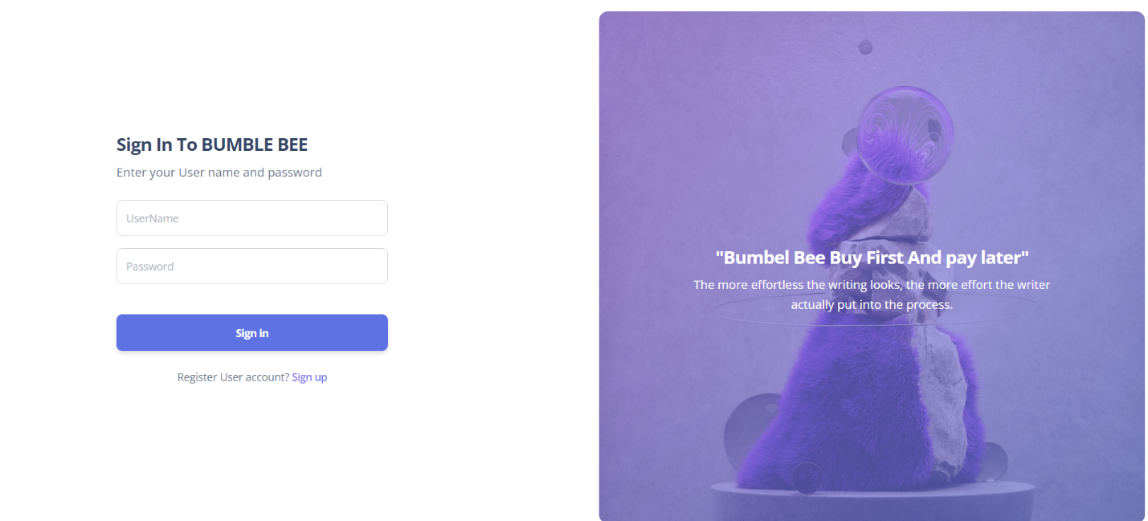

**Figure 7: login**

1. Sign in fail

When you enter a wrong user name or a password you will guide to error page as shown below

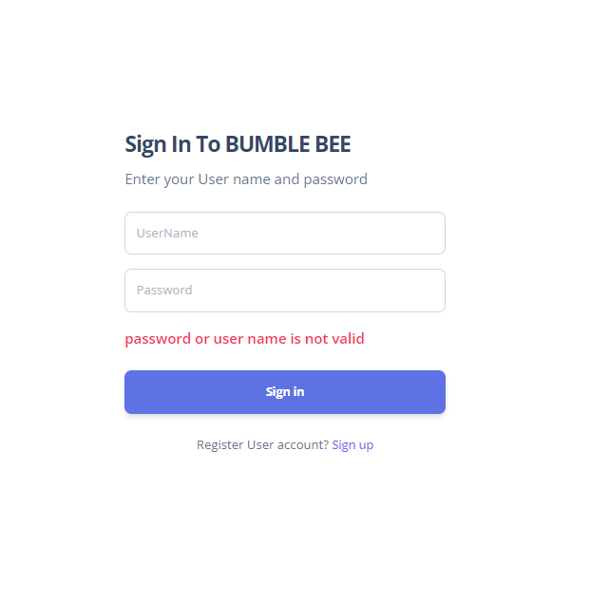

after successful login you will be presented with administrator dash board for bumble bee. 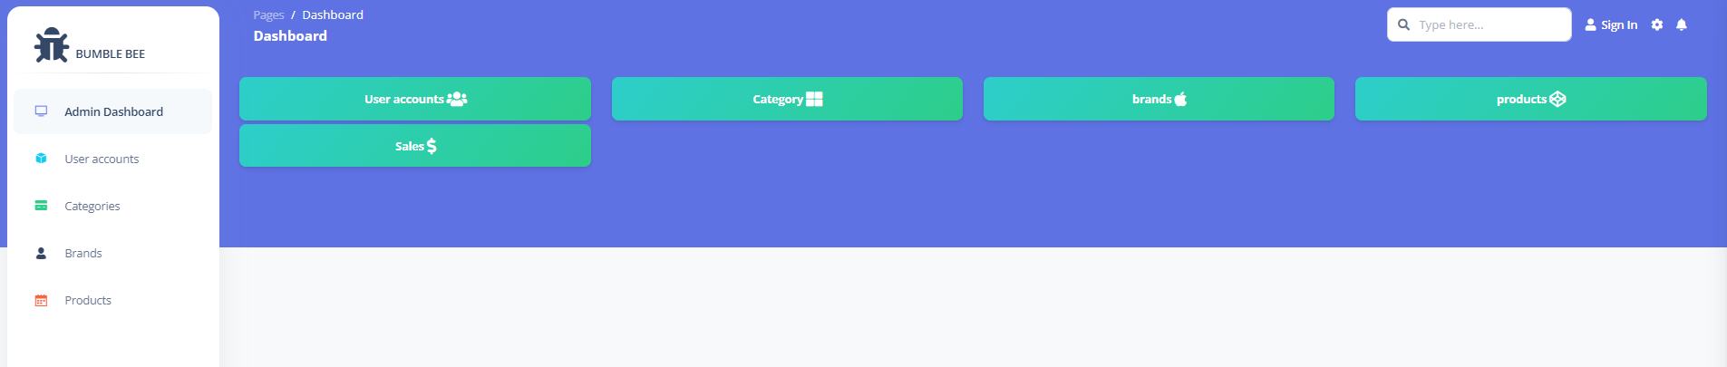

**Figure 8: dashboard**

1. User List and User information
2. To administrator there are certain privileges delete and edit users information is one on them.
3. To enter user information panel click as shown bellow.

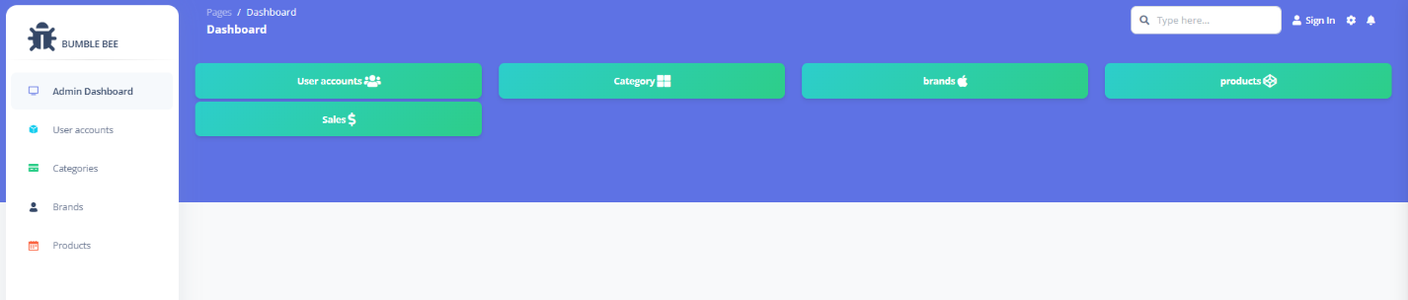

**Figure 8: dashboard**

1. To edit user information click Edit as below

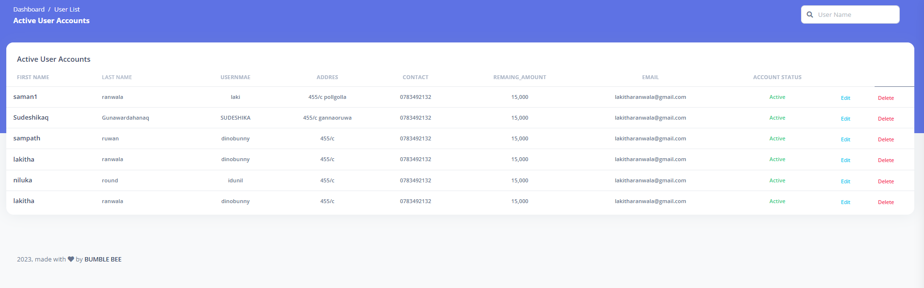

**Figure 9: user page**

1. Edit page edit respective information that you need and click edit button to complete your action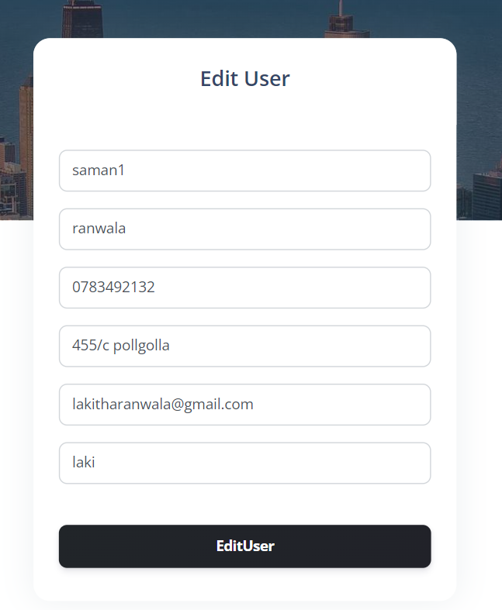

**Figure 10: user edit**

1. You will guide back to user information panel.
2. Add delete update product category’s
3. Click category tab in dashboard in order to get in



**Figure 11: dashboard**

1. To add category click green colour add button in to right conner

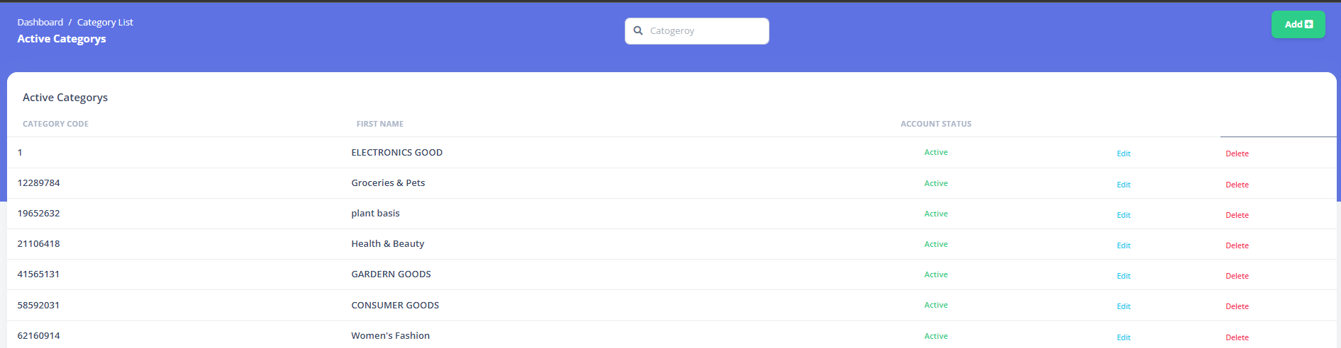

**Figure 12: categorys**

1. It will bring up this moden named as add

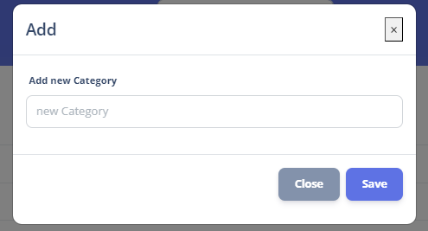

**Figure 13: add form**

1. Add a category and save



**Figure 14: add form**

1. To edit click edit button and it will bring up model named as edit



**Figure 14: category**

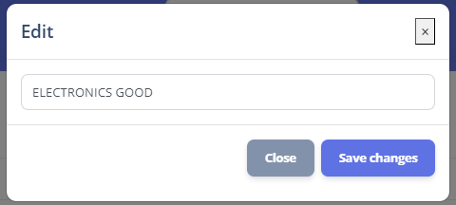

**Figure 15: edit category**

1. Click save changes to edit.
2. To delete a record simply just click delete in right conner



**Figure 15: category**

1. Add delete update product brands.
2. To enter brand section click brands tab in dashboard



**Figure 16: dashboard**

.

1. click add button in top right conner model will pop up as shown below
2. Add anew brand and save

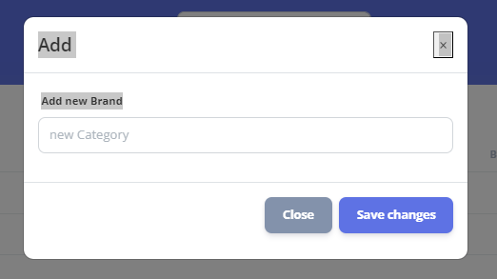

4 To edit click edit model will pop up as shown below. And give save changes

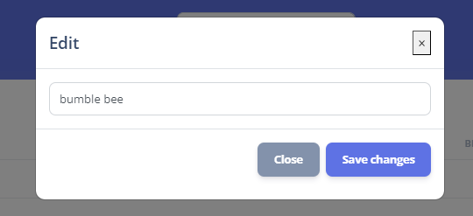.

**Figure 17: edit**



1. Add delete update products (Inventory management).
2. To get in to products click products tab in dashboard.



**Figure 18: dashboard**

1. To add new product go to top right conner and select add.
2. Add category from product.

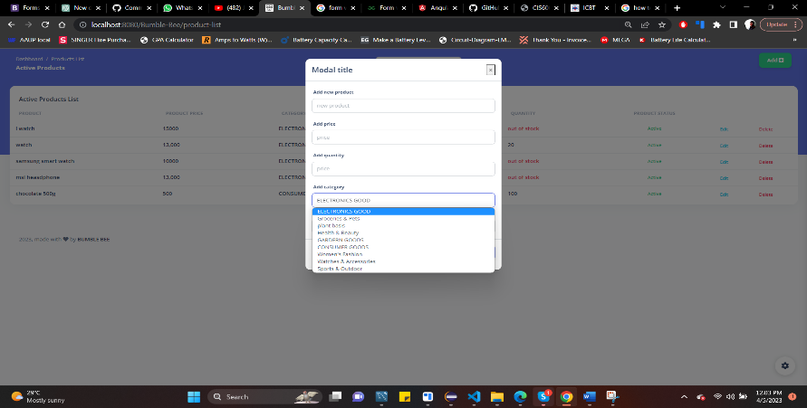

**Figure 19: product**

1. Add brand for product.

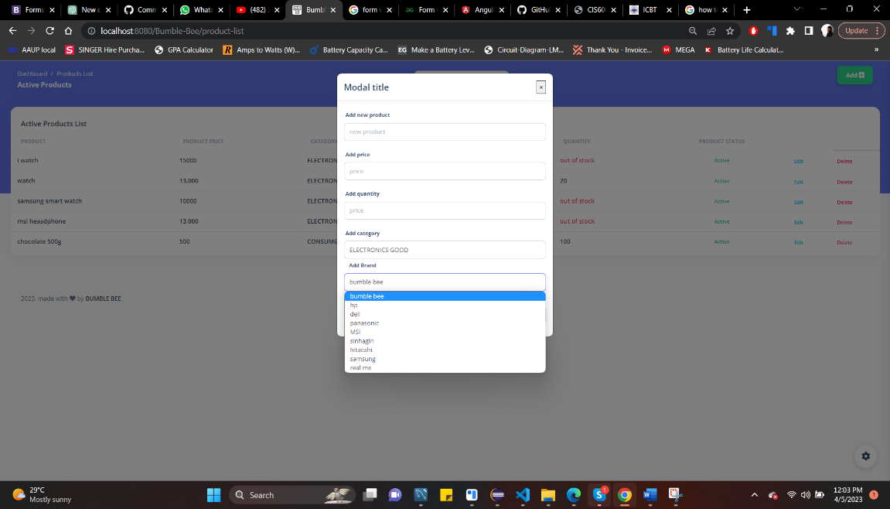

**Figure 20: product**

1. To edit click edit button

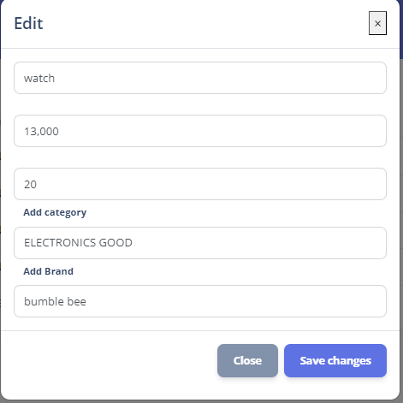.

**Figure 21: edit**

1. Sales tracking
2. To enter to sales table

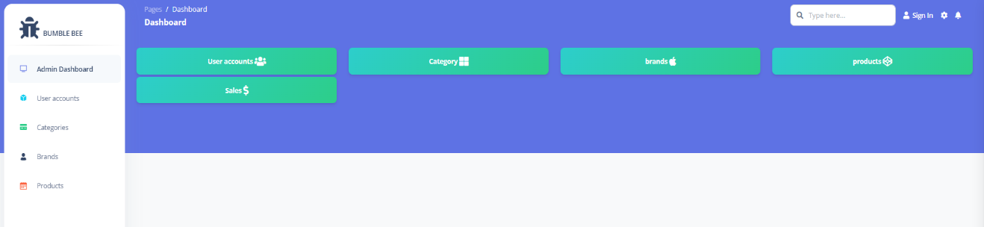

**Figure 22: dashboard**

1. You will parents with sales .

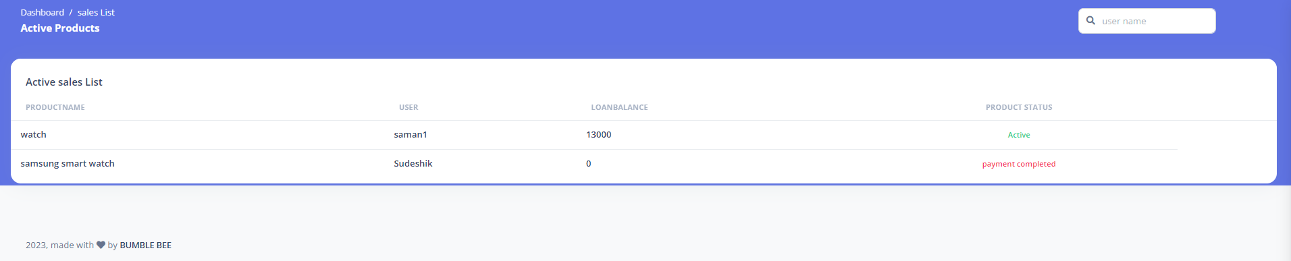

**Figure 21: sales**

1. Email ([bumblebeeassingment@gmail.com](mailto:bumblebeeassingment@gmail.com) /pw-0815673544abcd / app pw- cfknqmjrkhaevrjf)

By this feature you will receive a email after a successful registration

Note- if email service down or several time google banned the Gmail account.

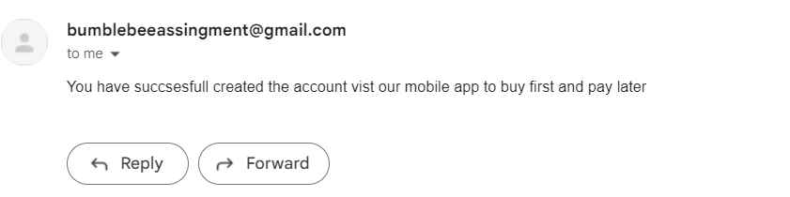

# 

# **References**

www.javatpoint.com. (n.d.). *Singleton Design Patterns - Javatpoint*. [online]

Available at: <https://www.javatpoint.com/singleton-design-pattern-in-java>.

www.javatpoint.com. (n.d.). *Creational Design Patterns - Javatpoint*. [online] Available at: <https://www.javatpoint.com/creational-design-patterns>.

www.javatpoint.com. (n.d.). *Builder Design Pattern - Javatpoint*. [online]

Available at: <https://www.javatpoint.com/builder-design-pattern>.

www.javatpoint.com. (n.d.). *Builder Design Pattern - Javatpoint*. [online]

Available at: <https://www.javatpoint.com/builder-design-pattern>.

www.javatpoint.com. (n.d.). *Abstract Factory Pattern - Javatpoint*. [online]

Available at: https://www.javatpoint.com/abstract-factory-pattern.

‌

‌